**MARKET PLACE HACKATHON 2025 DAY 03:**

**Day 3 - “API Integration Report – Rental E-Commerce"**

**Understanding API integration process.**

The below diagrams shows the data for provided API that is divided into two categories (for Popular cars and Recommended cars)

|  |  |  |
| --- | --- | --- |
| *Popular  Cars  API* | *Provided* *API* | *Recommended* *cars API* |

|  |  |  |
| --- | --- | --- |
| {  “id”: 1,  “name”: “Koenigsegg”,  “type”: “spot”,  “fuel-capacity”: “90l”,  “transmission”: “manual”,  “seating-capacity”: “2 People”,  “price-per-day": “$99.00”,  “image-URL”: car1,  “tags”: [“popular”],  “like-color” : redheart  }, | [  {  “id”: 1,  “name”: “Koenigsegg”,  “type”: “spot”,  “fuel-capacity”: “90l”,  “transmission”: “manual”,  “seating-capacity”: “2 People”,  “price-per-day": “$99.00”,  “image-URL”: “https://hackthone-3-template-07.vercel.app/”,  “tags”: [“Popular”]  },  ] | {  “id”; 12,  “name”: “Nissan Altima”,  “brand”: “Nissan”,  “type”: “hybrid”,  “fuel-capacity”: “50l”,  “transmission”: “Manual”,  “seating-capacity”: “5seats”,  “price-per-day": ”$90.00”,  “image-URL”: Car12,  “tags”: [“recommended “],  “like-color” : redheart  } |

* Key endpoint for API

The end-point for popular cars API and recommended cars API are as follows;

1. Api/popular-category
2. Apirecommended-category
3. VALIDATE AND ADJUSTMENT OF SCHEMA

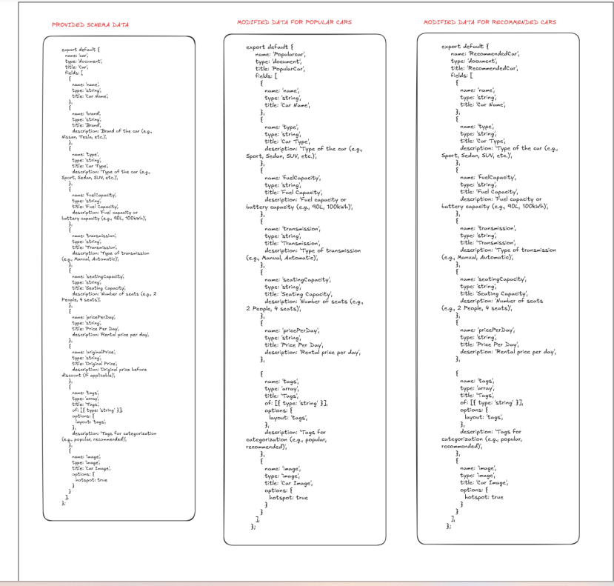

1. **DATA FETCHING FROM SANITY**

**Here ‘re the pictures mentioned in which clearly shows , that’ how data Fetch from sanity and migrate in the project**

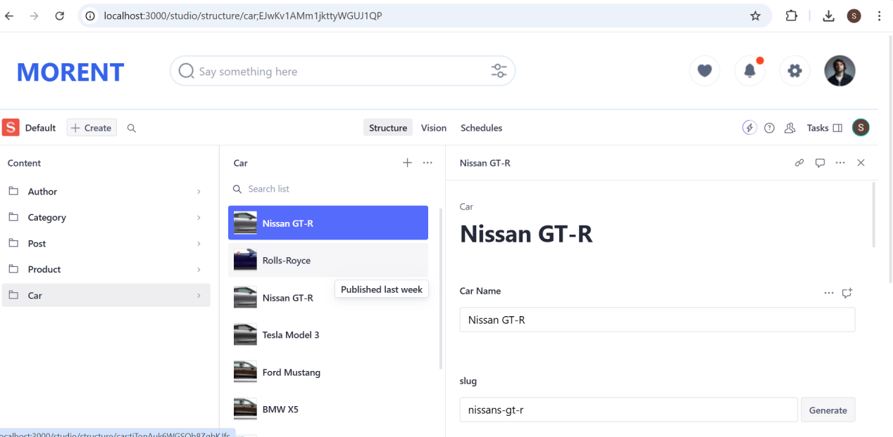

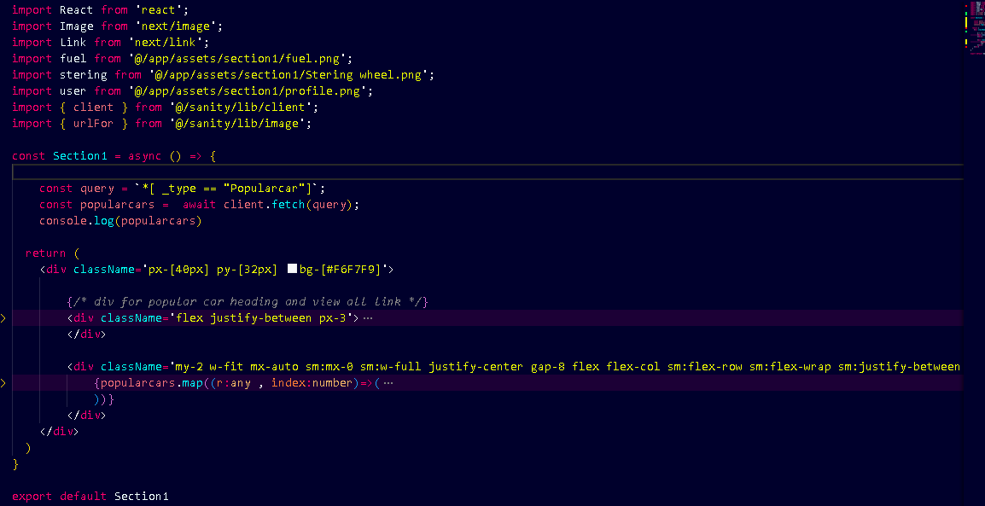

**4. DATA DISPLAY ON FRONTEND**

